Codecademy Jamming Project

I found this project to be a great opportunity to practice a lot of what I had learnt when undertaking the Codecademy lessons on React. It also helped me to start ‘thinking in React’. I followed the step-by-step instructions. Although this does not make the project my own, it did help me gain a deeper understanding of components and how to pass properties and functions and when to use states and event handlers.

I found it useful to work on an app where the css and styling had already been done for me. This allowed me to focus on the functionality and solidify my React knowledge, as I was able to test the functionality after each step in the process.

Once I had completed the project, I decided to test my understanding and retrospectively wireframe the project. This helped me to clarify the functionality and how functions and properties were passed between components.

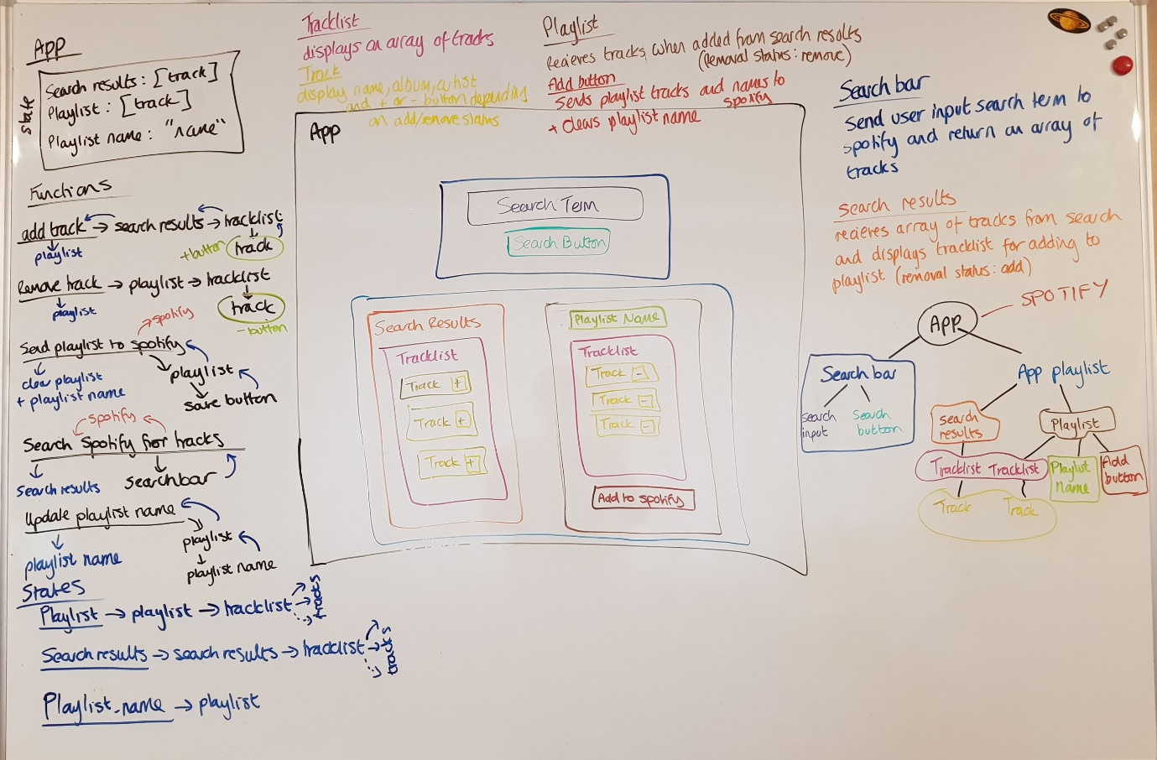

Although this was project was useful for practicing my use of React components, I did find myself having to follow along with the video when connecting the App to Spotify. This is something that had not been covered yet in the Codecademy lessons. I was able to follow along but cannot say that I fully understood all of the steps in the process.

There also seemed to be a missing instruction that meant the App would not function. The instructions did not tell you to add an onClick attribute to the search bar button. However, this was a simple fix.

**My own improvements**

Once I finished the project, I was not 100% happy with the functionality. I decided to fix the following two problems

* **Problem** The app would error if a user clicked to save a playlist when there were no tracks in the playlist.
* **Solution**
  + I added an if function to the apps save playlist method. This would check if the playlist was empty. If so, it would display an alert to the screen and exit the function.
* **Problem** The previous playlist name would be left in the playlist input after adding a new playlist. It was also possible to save multiple playlists with the default name “My playlist” or no name at all.
* **Solution**
  + First I split the Playlist into more components. The Tracklist was already its own component, so I added two more components – one for InputText for the playlist name and one for the SaveButton.
  + I moved the function to handle the name change into the InputText component and gave the return an id of “input-text”. I also changed the defaultValue to be a placeholder.
  + I moved the function to handle the save to SaveButton and included
    - document.getElementById("input-text").value = "";

in the handle save function so that the input would return back to empty and the placeholder would again display. This would also set the playlist name state of the app to empty. I set this initial value of the playlist name to also be empty to avoid the first playlist being saved as “My playlist”.

* **Problem** The search feature was clunky. It would not work with the enter button and the previous search term would not clear after a search had been executed
* **Solution**
  + I added an onkeypress attribute to the input
    - onKeyPress={this.keySearch}
  + To deal with the key press, I added a method called keySearch that would call on search if the key was ‘Enter’
    - keySearch(e) {
    - if (e.key === "Enter") {
    - this.search();
    - }
    - }
  + I gave the input an id of “search-bar” and added the following code to the search method
    - document.getElementById("search-bar").value = "";

to clear the search bar after a search had been executed.